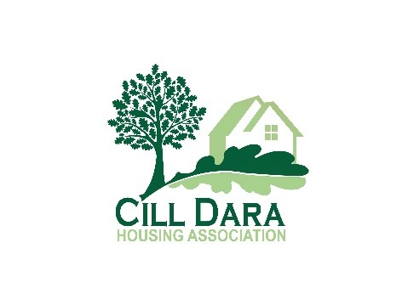 | Incident log | (045) 531 622  info@cilldarahousing.ie

Complainant |  | Telephone number (home)
Address |  | Email
Nature of complaint and premises

Date | Start  time | Finish time | Where/origin of noise | Description of incident / nuisance  Description / name of person causing nuisance | Impact on household / complainant

